INSTRUCTIONS

- La calificación obtenida de esta guía de trabajo será con nota parcial para quienes obtengan buenas notas y para quienes no puedan desarrollarla o saquen mala nota, NO se pondrá la nota en el libro, sino que se analizará su caso para darle la posibilidad de mejorar.
- Para completar la guía de trabajo vas a necesitar repasar en tus cuadernos y textos escolares de años anteriores y/o buscar información en Internet. Puedes usar todas las herramientas que tengas a tu alcance. Se recomienda: https://dictionary.cambridge.org/es/
- Para completar la guía de trabajo tienes 2 opciones:
- Escribe tus respuestas en la guía de trabajo
- De forma digital, marca tus respuestas . y envíalas al correo que esta en el punto 4.
- Al finalizar la guía de trabajo:
- Cambia el nombre del archivo.
“English Worksheet 4M 2020” tu nombre+apellido + curso + inglés
EJEMPLO: carlagonzalez 4B inglés
- Envíala al correo electrónico utp@insucovalpo.cl
- Hazla llegar al instituto con tu nombre+apellido y curso en los horarios que se van a informar.
- Los y las estudiantes, que no tengan acceso a Internet, deberán concurrir al establecimiento, desde las 10:00 a las 13:30 horas a retirar el material impreso.

ENGLISH WORKSHEET 4th GRADE
Name: __________________________________ Date:_____________Grade:___________
7.0 | 30 Points
4.0 | 15 Points
PASSING SCORING:

OBJETIVES
Recognize vocabulary to determine verb form and meaning by context | Select the best response in verbal exchanges. | Identify specific information and main idea.

1. | Match the sentences (1-4) with the MEME. (A-E). (2 points each: ____/8 POINTS)

1. You should wear a helmet.  2. This door must be closed.  3. You have to eat somewhere else. | A.  
4. You don’t have to go to the hospital for small injures. | 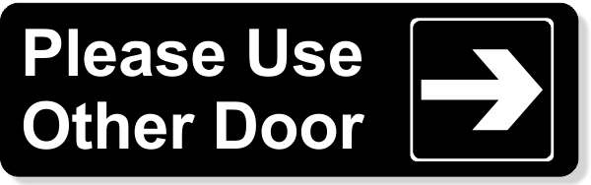  B.
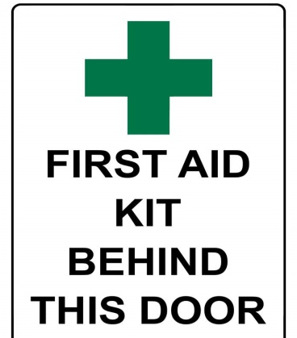
C.
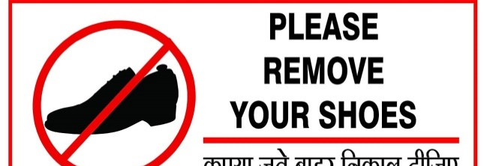
D.
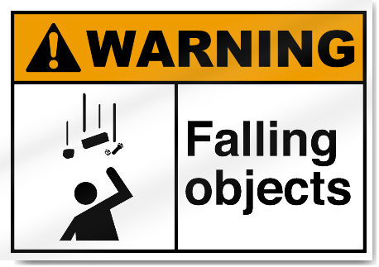
E.

2. | Complete the three conversations. For questions 5-7, choose A, B or C.  (2 points each: ____/6 POINTS)
5. Where does your brother work? |  | A. No, he isn’t.  B. He works in a Hotel.  C. My brother lives in Paris.
6. What do you do? |  | A. I am veterinarian.  B. No, I do not.  C. I work every day.
7. Is she the security guard? |  | A. She is from Talca.  B. Yes, she is. Her name is Karen.  C. Security is very important.


3. | Read the sentences about Health Checkups (8-10), and choose the best word (A, B or C) for each space.(2 points each: ____/6 POINTS)
8. Good health is important. It is important to see a doctor one or two times a year. The doctor can look at our bodies to ________ health problems and take care of them early.

A. Discovered B. Discovers C. Discover

9. In this way, it is often possible to avoid serious illness. In the picture, the young girl ________ having a checkup at a clinic. She has a pain in her throat so the doctor is looking in her mouth.

A. Am B. Is C. Are

10. Many people ________ the clinic every day for checkups. Doctors encourage people to take care of their bodies in order not to have health problems. It is better to be safe than sorry!

A. Go B. Goes C. Going

4. | Read the article about Ironworkers. Determine if the sentences from 11-15 are Right (A) or Wrong (B). If there is not enough information to answer right or wrong, choose Doesn’t Say (C).  (2 points each: ____/10 POINTS)

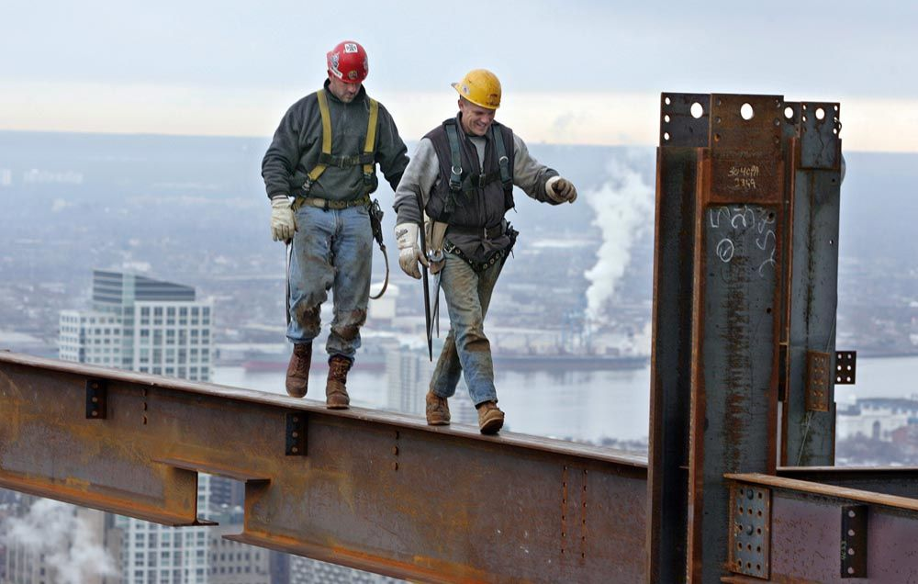
Workers on high buildings
Ironworkers build tall buildings (called skyscrapers). It is a very dangerous work, so they have to be careful all the time. They do not want to fall!
Ironworkers work together. They always work with another Ironworker because it is easy to fall; so it is important that they stay close to each other. In this way they help each other. Ironworkers never take chances. They learn from each other by asking questions. In this way they learn to trust fellow workers. They also learn by experience. Ironworkers enjoy their jobs because they like the danger of high places.
Spring is the best time of year to finish a job. Ironworkers like to finish a job in the spring. The cold winter is past and it is good to see the end of a job.

11. Skyscrapers are very tall buildings.

A. Right B. Wrong C. Doesn’t say

12. Ironworkers work alone.

A. Right B. Wrong C. Doesn’t say

13. In the morning, Ironworkers ask questions.

A. Right B. Wrong C. Doesn’t say

14. This job is very dangerous.

A. Right B. Wrong C. Doesn’t say

15. Ironworkers don’t work in spring time.

A. Right B. Wrong C. Doesn’t say

