Guía Evaluada: Unit 0: Reading

Nombre:_______________________________________Fecha:____________Curso:________Score: 24 pts. Evaluación: Sumativa Aprobación: 60% (15 pts nota 4.2) Tiempo: 45 MINUTOS
Objetivo: Los alumnos y las alumnas serán capaces de: Extraer información general y detalles de textos descriptivos, como folletos o artículos acerca de lugares turísticos, instalaciones y equipamiento turístico en general

- Discuss. (4 pts)
• Where are the following landmarks? What do you know about them?
• Which of them would you like to visit most? Why?

the Taj Mahal the Acropolis the Grand Canyon the Eiffel Tower Niagara Falls the Egyptian Pyramids

B. What is the purpose of the article? (1 pts)
- to educate the reader
- to inform and entertain the reader
- to encourage people to visit China

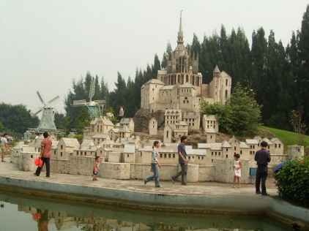
It’s a small world!

This week, in our series on the world’s most famous theme parks, we are visiting The Window of the World theme park in Shenzhen, China.

This certainly is a theme park with a difference. The Window of the World contains over 130 replicas of the most famous natural and manmade sites in the world, all squeezed onto about 480,000 square metres. Some of the replicas are the actual size of the sites while others are smaller. In one afternoon, you can visit the Eiffel Tower, walk around the Grand Canyon and marvel at the Egyptian Pyramids. The Acropolis is here along with Niagara Falls. One of the most interesting features of the park is the International Street, which features the Islamic Street, where you can see mosques, buildings and markets that look exactly like those found in the Arab world. ‘We want visitors to see and experience places and cultures they may not be able to actually get to in person. Not everyone can visit every famous landmark in the world in one lifetime and that is why this park is attractive to many visitors, both Chinese nationals and foreigners,’ commented Mr Chin, one of the managers.

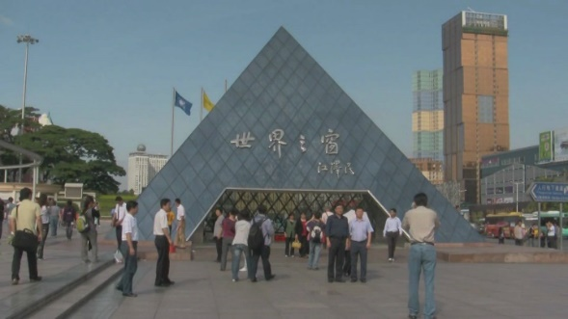
The Window of the World theme park combines both fun and education. There are regular exhibitions about famous people in history, and the park often holds festivals which focus on different countries and cultural themes. Visitors also have the opportunity to try out food from all over the world in one of the many restaurants. ‘This week we are holding Indian Week,’ explained one of the organisers. ‘Visitors can learn all about Indian culture, customs and traditions. We are offering Indian food all week and there is also a special exhibition on famous Indians in history.’

Visitors to the park not only have the opportunity to see many famous sites and learn a lot about different world cultures, but they also have the chance to take part in many adventure trips in the park. ‘We are waiting to go down the Colorado River by boat and some friends of ours are skiing in the Alpine Ski Resort,’ said one visitor. ‘We actually come from Shenzhen and we think this park is a great benefit for our region. We will probably never be able to visit all of these places ourselves, so it is really interesting for us. Some friends of ours are visiting us next week from the USA and we are going to bring them to see the park, too!’ In this theme park it really is a ‘small world’!

C. Read the article again. Decide whether the following statements are True, False or Not Mentioned in the article. Write T, F or NM. (6 Pts)
1. ________________ This article is the only one in the magazine on the topic of theme parks of the world.
2. ________________ All the exhibits on show are the same size as the originals.
3. ________________ The organizers of the park want visitors to learn something about different countries in the world.
4. ________________ You can try out food from different parts of China in the park.
5. ________________ Visitors can take part in sporting activities in the park.
6. ________________ The visitors are enthusiastic about the park.

D. Look at the following words/phrases highlighted in the article and choose the correct meaning a or b. (6 pts)

1. replicas
a. copies
b. pictures
2. squeezed onto
a. fitting into a small space
b. covering
3. marvel at
a. wonder about
b. admire
4. experience
a. to be in a particular situation
b. to remember a situation
5. combines
a. joins together
b. increases
6. holds
a. controls
b. organizes

• Would you like to visit the Window of the World theme park? Why / Why not? (4 pts)
________________________________________________________________________________________________________________________________________________________________________________________________________________________________________________________________________________________________________________________________________________________________________________________________________________________________________________________________________________________________________________________________________________
• What would you like to do there? (3 pts)
________________________________________________________________________________________________________________________________________________________________________________________________________________________________________________________________________________________________________________________________________________________________________________________________________________________________________________________________________________________________________________________________________________

