Worksheet on “Coronavirus”, 4th Grade

Name____________________Class_____________________Score: ______/ 20 pts.

AE02: Leer y demostrar comprensión de ideas principales e información relevante en textos descriptivos, informativos, narrativos y expositivos auténticos, simples y de variada extensión.

Tiempo estimado de desarrollo: max. 1 hora y media.
Habilidades a fortalecer: -Leer comprensivamente texto en Inglés.

I.- Instrucciones:

- Lea el texto
- Subraye las palabras que no conozca para luego consultar diccionario físico u online.
- Idealmente no traduzca oraciones o párrafos para que no se confunda
- Al término de la guía se deberá enviar con nombre y curso al correo que se indica en la página web o entregarla de forma presencial en los horarios difundidos en las plataformas del Instituto

“Be Healthy at home – Physical activity”

The COVID-19 pandemic means that many of us are staying at home and sitting down more than we usually do. It’s hard for a lot of us to do the sort of exercise we normally do. It’s even harder for people who don’t usually do a lot of physical exercise.

But at a time like this, it’s very important for people of all ages and abilities to be as active as possible. WHO’s “Be Active” campaign aims to help you do just that - and to have some fun at the same time.

Remember - Just taking a short break from sitting, by doing 3-4 minutes of light intensity physical movement, such as walking or stretching, will help ease your muscles and improve blood circulation and muscle activity.

Regular physical activity benefits both the body and mind. It can reduce high blood pressure, help manage weight and reduce the risk of heart disease, type 2 diabetes, and various cancers - all conditions that can increase susceptibility to COVID-19.

It also improves bone and muscle strength and increases balance, flexibility and fitness.
Regular physical activity can help give our days a routine and be a way to stay in contact with family and friends. It’s also good for our mental health - reducing the risk of depression, cognitive decline.

How much physical activity is recommended for your age group?
Children and adolescents aged 5-17 years:

• All children and adolescents should do at least 60 minutes a day of moderate to vigorous-intensity physical activity
• This should include activities that strengthen muscle and bone, at least 3 days per week
• Doing more than 60 minutes of physical activity daily will provide additional health benefits.

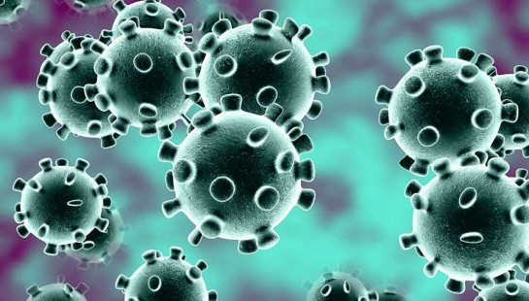

II.- Lea el texto nuevamente y escriba si las oraciones a continuación son falsas o verdaderas.(1pto c/u)

a)_______ The text is about the physical exercise you do on pandemic.
b)_______ It is not important to be active.
c)_______ WHO : World Health Organization.
d)_______ Regular physical activity benefits ONLY the body.

e)_______ Physical activity also reduces the risk of depression.

f)_______ Adolescents should do only 30 minutes of exercise.

III. Lee las oraciones y subraya la alternativa correcta según el texto leído.(1 pto c/u)

- Covid 19 is: a) the name of a hospital b) the name of a city c) a pandemic.

- The “Be Active” is a: a) campaign b) a game c) tv programme.

- Two conditions that can increase susceptibility to COVID 19 are :

- Body and mind b) type 2 diabetes and cancer c) bone and muscle strength

- To have physical activity is good for:

- Our mental health b) reducing the risk of depression c) A and B.

IV. Complete la oración con las palabras dadas, de acuerdo al texto anterior .(2 pts c/u)

1.- risk of heart disease | 2.-WHO | 3.- physical exercise | 4.-health | 5.- active

1. - The text is about the __________________ during pandemic.

2. - People of all ages must be _________________ in this period of pandemic.

3. - ___________________________ means “riesgo de enfermedades al corazón”.

4.-_________ means “organización mundial de la Salud”

5. - Exercise is also good for mental ____________ .

V.- Responda en Castellano.
¿Qué fue lo que más te costó hacer? ¿Por qué?

BE SAFE , STAY HOME!!
Correo de prof : maramansillam@yahoo.com ( consultas)
Al terminar la guía, deberá enviarla con nombre, curso y fecha de entrega al correo guias@insucovalpo.cl o entregarla en forma presencial en el Liceo, los días martes y jueves de 9,30 a 13 hrs.

